POSTFIX :

sudo apt install postfix
sudo apt install mailutils
Modifier le fichier /etc/postfix/main.cf comme ci-dessous

smtpd_relay_restrictions = permit_mynetworks permit_sasl_authenticated defer_unauth_destination
myhostname = Mail.SocieteX.lan
mydomain = SocieteX.lan
alias_database = hash:/etc/aliases
myorigin = /etc/mailname
mydestination = Mail.SocieteX.lan, localhost.SocieteX.lan, localhost, SocieteX.lan
relayhost =
mynetworks = 127.0.0.0/8 [::ffff:127.0.0.0]/104 [::1]/128
mailbox_size_limit = 0
recipient_delimiter = +
inet_interfaces = all
inet_protocols = all

- On restart ensuite le service service postfix restart
- On crée 2 utilisateurs avec la commande adduser
- On se rend sur l’utilsateur1 et on fait la commande mail -s ‘Sujet” <récepteur>
user 1
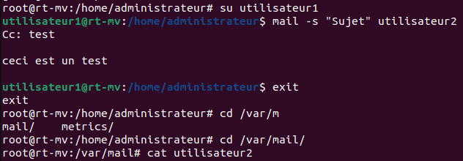
user 2
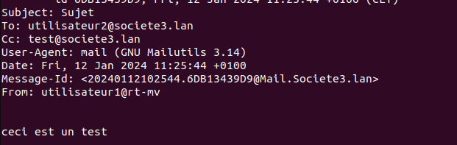

/etc/postfix/main.cf

# See /usr/share/postfix/main.cf.dist for a commented, more complete version

# Debian specific: Specifying a file name will cause the first
# line of that file to be used as the name. The Debian default
# is /etc/mailname.
#myorigin = /etc/mailname

smtpd_banner = $myhostname ESMTP $mail_name (Ubuntu)
biff = no

# appending .domain is the MUA's job.
append_dot_mydomain = no

# Uncomment the next line to generate "delayed mail" warnings
#delay_warning_time = 4h

readme_directory = no

# See http://www.postfix.org/COMPATIBILITY_README.html -- default to 3.6 on
# fresh installs.
compatibility_level = 3.6

# TLS parameters
smtpd_tls_cert_file=/etc/ssl/certs/ssl-cert-snakeoil.pem
smtpd_tls_key_file=/etc/ssl/private/ssl-cert-snakeoil.key
smtpd_tls_security_level=may

smtp_tls_CApath=/etc/ssl/certs
smtp_tls_security_level=may
smtp_tls_session_cache_database = btree:${data_directory}/smtp_scache

smtpd_relay_restrictions = permit_mynetworks permit_sasl_authenticated defer_unauth_destination
myhostname = Mail.societe2.lan
mydomain = societe2.lan
alias_maps = hash:/etc/aliases
alias_database = hash:/etc/aliases
myorigin = /etc/mailname
mydestination = Mail.societe2.lan, localhost.societe2.lan, localhost, societe2.lan
relayhost =
mynetworks = 127.0.0.0/8 [::ffff:127.0.0.0]/104 [::1]/128
mailbox_size_limit = 0
recipient_delimiter = +
inet_interfaces = all
inet_protocols = all

